User engagement through multimodal feedback and involvement in game design with a wearable interface

Carlos Arce-Lopera[1],* and Arturo Gomez1

1 Universidad Icesi, Calle 18 No. 122-135 Pance, Cali, Colombia

{[caarce, arturo.gomez}@](mailto:caarce,%20arturo.gomez%7d@)icesi.edu.co

**Abstract.** A wearable interface was designed, built and tested as a prototype to evaluate users’ engagement in a game setting. The wearable interface consisted of a light sensor and three different types of actuators: a RGB led, a buzzer and a vibe motor. Evaluations of the interface performance were conducted focusing on two main components: the multimodal feedback system and the involvement in game design over several rounds. Experimental results showed that our wearable interface is comfortable and imperceptible. Moreover, our wearable interface is simple enough for users to be able to add game modes based on social agreements. Our results demonstrate how meaningful multimodal feedback and self-directed involvement in game design can address several human factors challenges faced by user engagement designers.

**Keywords:** Human Factors · Game Design · User Engagement · Wearable Interface · Multi-modal Feedback

1. Introduction

User Engagement (UE) is a measure of the quality of the user experience when interacting with an interface. However, its practical measurement has been proven to be challenging to define, design for, and evaluate [1]. To understand the complexity of user engagement, several theories have been described [2]. For example, the self-determination theory, classifies motivation, which can be directly related to UE, into two categories: intrinsic and extrinsic motivation. The intrinsic motivation is driven by the user´s feelings of autonomy, competence and relatedness. On the other hand, the extrinsic motivation is directed by external factors, such as rewards or threats [3]. This example shows the multidimensionality of the concept of user engagement and the necessity for specific and diverse measuring tools.

One popular measuring tool is the User Engagement Scale (UES), a 31-item questionnaire, that classifies UE in six different dimensions [4]. However, by recognizing the difficulty to measure such a long scale for each subject and trial, several researchers have improved and reviewed the UES. The short versions include only four dimensions: Focused attention, Perceived usability, Aesthetic appeal and Reward or Satisfaction factor [1], [4]. Focused attention refers to the feeling of been absorbed in the interaction by losing the track of time. The Perceived usability is the perceived degree of control and effort experienced. The Aesthetic appeal is the attractiveness of the interface according to our aesthetic perception using all senses. The last dimension, the Reward factor, is a combination of the overall success of the interaction, the sense of having fun, and the curiosity and interest for the interaction.

To be able to test for UE of a novel wearable interface in a game setting, we decided to test the importance of the self-directed, meaningful involvement with game design as a powerful tool to increase user engagement [5]. Additionally, meaningful game elements such as multimodal feedback, can give new insights and understanding on ways to retain the attention of users and customers.

1. Methods
   1. Apparatus

The wearable interface consisted of a light sensor and three different types of actuators: a RGB led, a buzzer and a vibe motor. All components were connected to a Lilypad Arduino using a conductive thread (see Fig. 1). Therefore, the multimodal feedback stimuli was designed as a combination of audio, tactile and visual information.

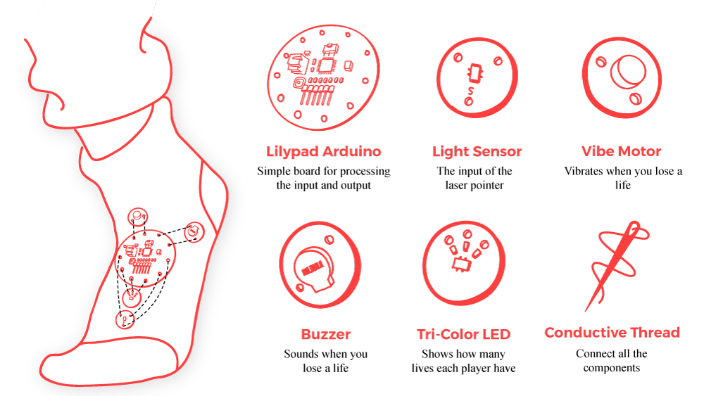

**Fig. 1.** Wearable Interface Components

The electronic components were sewed into socks that the users have to wear in one foot. A conventional laser pointer was given to be used in conjunction with the light sensor to activate the interaction. When the laser pointed to the light sensor, the feedback system was activated (see Fig. 2).

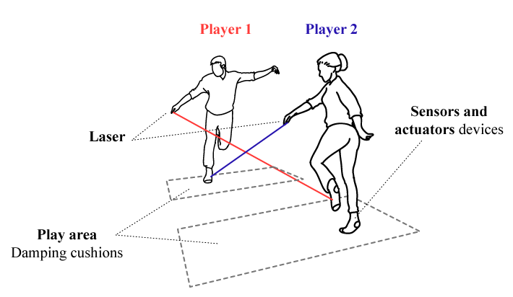**Fig. 2.** Wearable Interface with Multi-Modal Feedback

* 1. Subjects and Task

Ten volunteers (three males and seven females; 19 years old in average) participated in the evaluation of the interface. All were naive to the purpose of the study and were instructed to wear the interface in their dominant foot. We asked participants to play a total of four rounds. In each round, they were instructed to abide by fixed rules or to change the rules for the next round. The order of the latter instruction was randomized for each game of four rounds always ensuring that players had two rounds with fixed rules and two rounds with socially mediated rules.

* 1. Evaluation

We designed and conducted evaluations of the interface performance focusing on two main components: the multimodal feedback system, and the involvement in game design over several rounds. The NASA-TLX was used as a tool to assess the perceived workload for each player on each round. Also, players’ accuracy and response time were recorded by the wearable interface. To evaluate user engagement, the game sessions were recorded on video and analyzed manually to extract the different game strategies but also human gestures associated with frustration or enjoyment. This approach is fundamentally different from the UES questionnaire where the responses are bias by the user’s perceptions of their interaction. Here, the four dimensions of UE, were deducted from a combination of user perceptions (NASA-TLX), quantitative objective data (from the wearable interface) and subjective interpretation by qualified evaluators (video analysis).

1. Results
   1. Multi-Modal Feedback System Evaluation

Experimental results show that the wearable interface is comfortable and imperceptible during the development of the game since the players understood the meaning of each multimodal feedback from the first round. The users were not instructed about how to interpret the feedback system nor were they aware of its multimodality. They only were told to point to the opponent light sensor to initiate the competitive interaction. All users associated the visual feedback with the status of the player in the game; the green light was associated with the start of the game, the yellow light was related to a warning to a possible loss of the round and the red light was associated with the end of the interaction. The color metaphor that resembles the traffic light rules was selected by the users for their interaction. The tactile feedback was given when the light sensor was activated; one vibration of two seconds meant a hit (light sensor activation) and two consecutive vibrations meant the end of the round. Lastly, the audio feedback indicated the start and ending of the round and the activation of the light sensor using different sounds. In summary, the wearable interface with a multimodal feedback that reinforces the meaningful aspects of the interaction was successful in conveying simple and concrete feedback that support the interaction without introducing confusion or frustration with the interface.

* 1. Involvement in Game Design

Involvement in game design as a strategy to increase UE is difficult to measure. For this reason, we used a mixed approach with a combination of self-reported user perception, quantitative recording of response time and events by the interface and a subjective video analysis of the interaction. By combining, these three sources of information, the four dimensions of UE can be derived and then contrasted between the two conditions, with or without fixed rules.

**Fig. 3.** Nasa TLX results.

The involvement in game design, which were socially mediated instead of imposed increased user engagement. This skewed engagement became evident as the users perceived the game with socially mediated rules as more physically demanding and required more effort (see Fig. 3). The mental demand, performance perception and perceived frustration was not significantly different between the two conditions. However, the users perceived that the temporal demand was lower when the rules were self-imposed by them. Additionally, the time spend in the socially mediated rules condition was in average 20 % longer than the time spend in the fixed rule condition.

**Fig. 4.** Video Analysis Results.

In addition, the video recordings showed increased gestures of enjoyment when the game obeyed the self-imposed rules. The subjective video analysis (see Fig. 4) classified users in three different categories depending to expressions of frustration, laughter and self-reported satisfaction and commentary by users. The three classes were excellent, very good and good. The difference between the classes were the number of interactions, the number of laughs or frustration expressions interpreted in the video. The results showed that the socially mediated rules rounds were classified with greater likelihood in the top class than the fixed rules condition. The expressions of enjoyment, such as laughter and jokes increased by 20% as well as interactions between players, such as speech and physical contact. This did not only happened during the rounds but also before and after each round. Although the physical and social effort was greater without fixed rules, the level of satisfaction was greater too.

The four dimension of UE, namely the Aesthetic appeal, Perceived usability, Focused attention, and Reward Factor, can be derived from our results. The Aesthetic appeal of our interface was evaluated by implementing a multimodal feedback system that ensured an imperceptible feedback with congruent multimodal information of meaningful interactions. The Perceived usability was evaluated for both, test and control conditions (with or without fixed rules) using the NASA-TLX instrument and video analysis. The results showed that the fixed rule condition had a lower perceived usability. The Focused attention dimension of UE was measured using a combination of recorded response time, NASA-TLX responses and video analysis. The results showed that when in the socially mediated rules condition, users spend more time but felt that the temporal demand was lower. Finally, the Reward factor was tested with the video analysis and commentaries from the users. Users responses agreed that self-directed rules were more engaging and satisfying.

1. Conclusion

We introduced a wearable interface that is comfortable and imperceptible. The interface is simple enough for users to be able to add game modes based on social agreements which demonstrates how meaningful multimodal feedback and self-directed involvement in game design can tackle several human factors challenges faced by user engagement designers.

References

1. O’Brien, H.L., Cairns, P., Hall, M.: A practical approach to measuring user engagement with the refined user engagement scale (UES) and new UES short form. Int. J. Hum.-Comput. Stud. 112, 28--39 (2018)

2. Silpasuwanchai, C., Ren, X.: A Quick Look at Game Engagement Theories. In: Norman, K.L., Kirakowski,, J. (eds.) The Wiley Handbook of Human Computer Interaction. John Wiley & Sons, Ltd, pp. 657--679. (2018)

3. Ryan, R.M., Deci, E.L.: Self-determination theory and the facilitation of intrinsic motivation, social development, and well-being. Am. Psychol.55, 68--78 (2000)

4. Wiebe, E.N., Lamb, A., Hardy, M., Sharek, D.: Measuring engagement in video game-based environments: Investigation of the User Engagement Scale. Comput. Hum. Behav. 32, 123--132 (2014)

5. O’Brien, H.L., Toms, E.G.: What is user engagement? A conceptual framework for defining user engage-ment with technology. J. Am. Soc. Inf. Sci. Technol. 59, 938--955 (2008)

1.